SSL certificate added in sub domain

Login : 10.0.1.212

ss_ssl ngbclient.tayana.in

DON’T Press ENTER to Continue

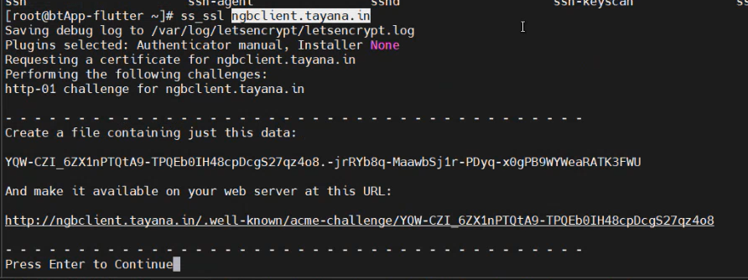

Login: 10.0.3.208

vi /opt/tcare/.well-known/acme-challenge/YQW-CZI_6ZX1nPTQtA9-TPQXXXXXXXXXqz4o8

Need to create a file with same name which is created from 1.212

After opened the file

Content you can copy from 1.212

YQW-CZI_6zX1XXXXXXXXXXXXXXXXXXXXXXXXXXX3FWU

Paste in 3.208 which is file created then you can paste and save it

After save the file you can go to 1.212 Press ENTER to Continue NOW.

Certificate is saved at : /etc/letsencrypt/live/ngblient.tayana.in/fullchain.pem

Key is saved at : /etc/letsencrypt/live/ngbclient.tayana.in/privkey.pem

Copy the above two paths from there



Restart the service

